Practical no.10

sepal_length sepal_width

0 5.1 3.5

1 4.9 3.0

2 4.7 3.2

3 4.6 3.1

4 5.0 3.6

petal_length

1.4

1.4

1.3

1.5

1.4

petal_width species

0.2

0.2

0.2

0.2

0.2

setosa setosa setosa setosa setosa

Title of the Assignment: Data Visualization III

Download the Iris flower dataset or any other dataset into a DataFrame. (e.g.,

https://archive.ics.uci.edu/ml/datasets/Iris ). Scan the dataset and give the inference as:

1. List down the features and their types (e.g., numeric, nominal) available in the dataset.
2. Create a histogram for each feature in the dataset to illustrate the feature distributions.
3. Create a box plot for each feature in the dataset.
4. Compare distributions and identify outliers.

import pandas as pd import seaborn as sns

iris_df = sns.load_dataset('iris') iris_df.head()

iris_df.dtypes

sepal_length sepal_width petal_length petal_width species

float64 float64 float64 float64 object

dtype: object

import matplotlib.pyplot as plt import seaborn as sns

fig, axes = plt.subplots(2, 2, figsize=(10, 10))

features = ['sepal_length', 'sepal_width', 'petal_length', 'petal_width']

for i, feature in enumerate(features): ax = axes[i//2, i%2] *# Determine the position in the 2x2 grid* sns.histplot(iris_df[feature], kde=True, bins=20, ax=ax) *# Histogram with KDE (Kernel Density Estimate)* ax.set_title(f"Histogram of {feature}")

plt.tight_layout() plt.show()

in a future version. Convert inf values to NaN before operating instead. with pd.option_context('mode.use_inf_as_na', True): C:\ProgramData\anaconda3\Lib\site-packages\seaborn\_oldcore.py:1119: FutureWarning: use_inf_as_na option is deprecated and will be removed in a future version. Convert inf values to NaN before operating instead. with pd.option_context('mode.use_inf_as_na', True): C:\ProgramData\anaconda3\Lib\site-packages\seaborn\_oldcore.py:1119: FutureWarning: use_inf_as_na option is deprecated and will be removed in a future version. Convert inf values to NaN before operating instead. with pd.option_context('mode.use_inf_as_na', True): C:\ProgramData\anaconda3\Lib\site-packages\seaborn\_oldcore.py:1119: FutureWarning: use_inf_as_na option is deprecated and will be removed in a future version. Convert inf values to NaN before operating instead. with pd.option_context('mode.use_inf_as_na', True):

FutureWarning: use_inf_as_na option is deprecated and will be removed

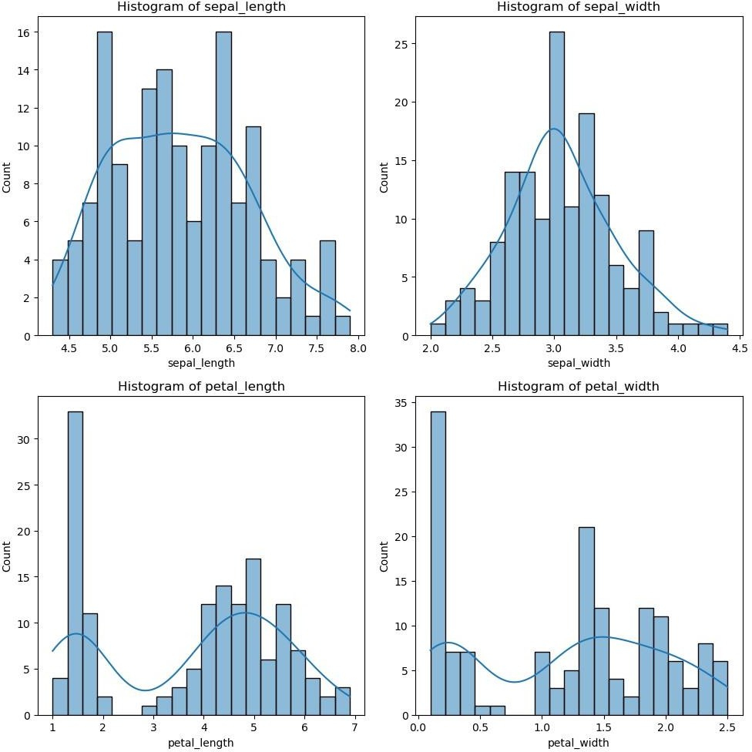

fig, axes = plt.subplots(2, 2, figsize=(10, 10))

for i, feature in enumerate(features): *Determine the position in the 2x2 grid* sns.boxplot(x=iris_df[feature], ax=ax) of {feature}")

ax = axes[i//2, i%2] *#*

ax.set_title(f"Boxplot

plt.tight_layout() plt.show()

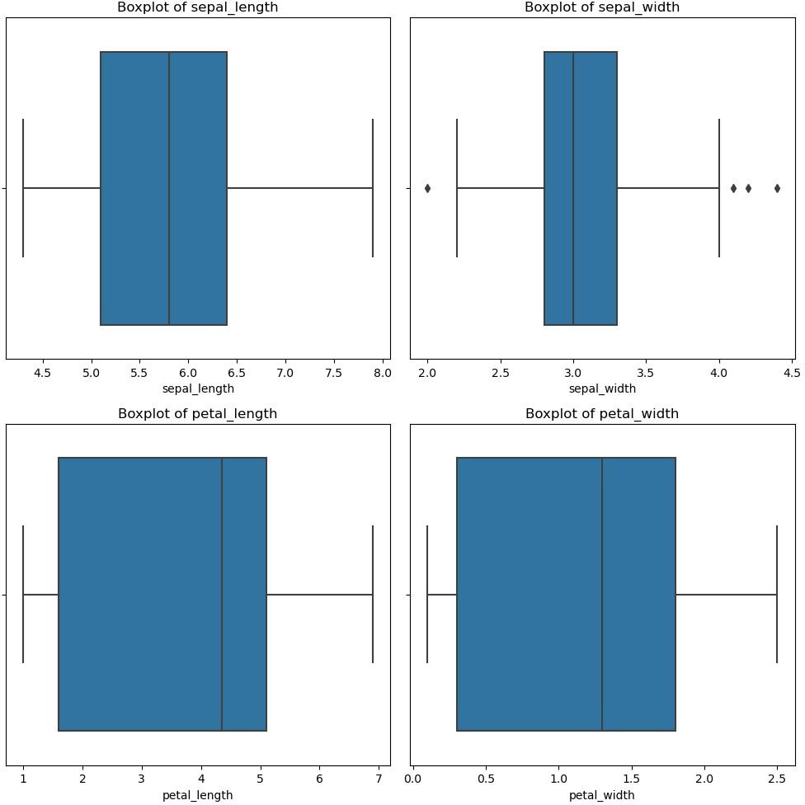

Name:Vaishnavi

Roll no: 13208 Batch: B1